

**North South University**

**Department of Electrical & Computer Engineering**

**LAB REPORT**

**Analog Electronics Lab**

**EEE111L**

**Experiment Number:** 3

**Experiment Name:** **Clipper and Clumper Circuit**

**Experiment Date:** 8/11/2021

**Report Submission Date:** 15/11/2021

**Section:** 7 **Group No:** 2

**Students Name & ID:**

1. Yusuf Abdullah Tonmoy – 1620456042 **(Report Writer)**
2. Fardin Bin Islam - 1721588642
3. Md Kawser Islam – 1912296642
4. Tusher Saha Nirjhor – 1921793642
5. Md. Rifat Ahmed – 1931725042

|  |  |  |
| --- | --- | --- |
| **Remarks:** | Score |  |
|  |  |
|  |  |  |
|  |  |  |

**Objectives:**

• Our objective in this experiment is to study Clipper and Clamper circuits.

**Theory:**

**Clippers:** Clippers are networks that employ diodes to “clip” away from a portion of an input signal without distorting the remaining part of the applied waveform. The half-wave rectifier is an example of the simplest form of diode clipper one resistor and a diode. Depending on the orientation of the diode, the positive or negative region of the applied signal is “clipped” off.

There are two general categories of clippers: series and parallel.

Series clipper configuration is the one where the diode is in series with the load and Parallel clipper configuration has a diode in a branch parallel to the load.

**Series Clipper circuit:** The diode in a series clipper “clip” any voltage that does not forward bias it.

**Series Biased Clipper circuit:**

Adding a DC source in series with the clipping diode changes the effective forward bias of the diode. The addition of a dc supply to the network as shown can have a pronounced effect on the analysis of the series clipper configuration. Any positive voltage of the supply will try to turn the diode on by establishing a conventional current through the diode that matches the arrow in the diode symbol. However, the added dc supply V will oppose that applied voltage and try to keep the diode in the “off” state. The result is that any supply voltage greater than V volts will turn the diode on and conduction can be established through the load resistor.

**Parallel Clipper circuit:**

The diode in a parallel clipper circuit “clips” any voltage that forward biases it.

**Parallel Biased Clipper circuit:**

The polarity of the dc supply and the direction of the diode suggest that the diode will be in the “on” state for a good portion of the negative region of the input signal. Since the output is direct across the series combination, when the diode is in it short-circuit state the output voltage will be directly across the ‘V’ DC supply, requiring that the output be fixed at ‘V’ DC supply. In other words, when the diode is on the output will be ‘V’. Other than that, when the diode is an open circuit, the current through the series network will be 0 mA and the voltage drop across the resistor will be 0 V. That will result in vo = vi whenever the diode is off.

Using a biased diode, it is possible to limit the output voltage to a specified level depending on the attached battery voltage. Either the half-cycles or both of them can be clipped off above a specified level.

In the practical case for both the series and parallel clippers, the voltage source is not added. Required voltage levels are maintained by adding more semiconductor diodes.

**Clampers:**

A clamper is a network constructed of a diode, a resistor, and a capacitor that shifts a waveform to a different dc level without changing the appearance of the applied signal. Clamping networks have a capacitor connected directly from input to output with a resistive element in parallel with the output signal.

**Equipment List:**

• p-n junction diode (1N4007) – 1 piece

• Resistor (10kΩ) – 1 piece

• Capacitor (0.1 µF) – 1 piece each

• Signal generator

• Trainer Board

• DC Power Supply

• Oscilloscope

• Digital Multimeter

• Cords and wires

**Circuit Diagram:**

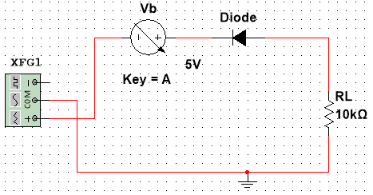

Figure – 1 (a): Series Clipper Circuit

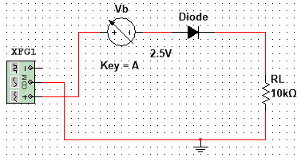

Figure – 1 (b): Series Clipper Circuit

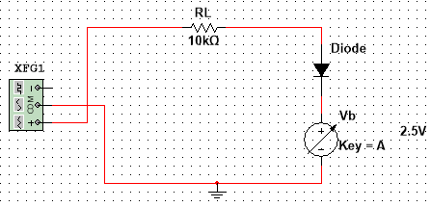

Figure – 2 (a): Parallel Clipper Circuit

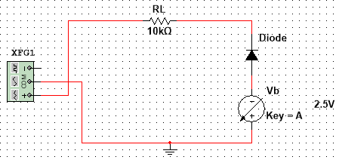

Figure – 2 (b): Parallel Clipper Circuit

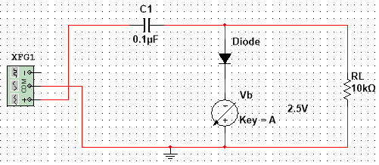

Figure – 3 (a): Clamper Circuit

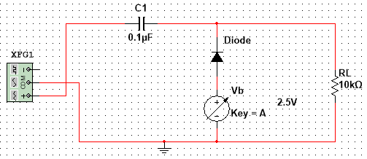

Figure – 3 (b): Clamper Circuit

**Data & Table:**

Theoretical Value: R = 10kΩ

Measured Value: R = 10kΩ

Vs = 10V(p-p)

|  |  |  |  |  |  |  |
| --- | --- | --- | --- | --- | --- | --- |
| **(Vb)** | Vo (p-p) | | | | | |
| Fig 4.6 | | Fig 4.7 | | Fig 4.8 | |
| (a) | (b) | (a) | (b) | (a) | (b) |
| 0 | 4.37V | 4.37V | 5.63V | 5.63V | 10.6V | 10.6V |
| 1 | 3.37V | 3.37V | 6.63V | 6.63V | 10.4V | 10.4V |
| 2 | 2.38V | 2.38V | 7.62V | 7.62V | 10.3V | 10.3V |
| **2.5** | 1.89V | 1.89V | 8.11V | 8.11V | 10.3V  Vmax= -1.53V  Vmin= -11.8V | 10.3V  Vmax= 11.8V  Vmin= 1.53V |
| 3 | 1.4V | 1.4V | 8.6V | 8.6V | 10.3V | 10.3V |
| 4 | 426mV | 426mV | 9.57V | 9.57V | 10.3V | 10.3V |
| 5 | 0V | 0V | 10V | 10V | 10.3V | 10.3V |

Table - 1

**Graphs:**

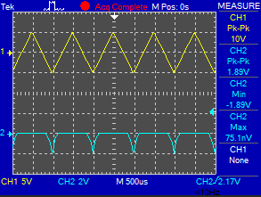 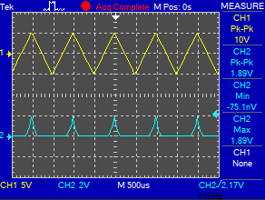

Figure 4 (a): Input-Output of Fig 1 (a) Figure 4 (b): Input-Output of Fig 1 (b)

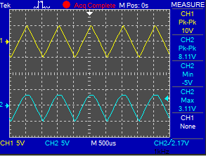 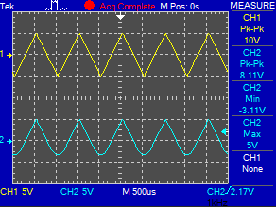

Figure 5 (a): Input-Output of Fig 2 (a) Figure 5 (b): Input-Output of Fig 2 (b)

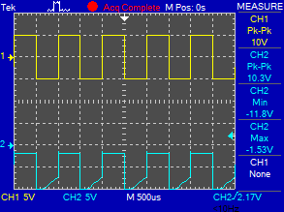 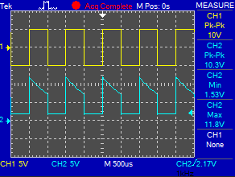

Figure 6 (a): Input-Output of Fig 3 (a) Figure 6 (b): Input-Output of Fig 3 (b)

**Result Analysis & Discussion:**

The name of the experiment is Clipper and Clamper circuit. In this experiment we have learn how to create a clipper circuit as well as the clamper circuit. And also learn the how to give an input voltage and observe the output of the waveform. Clipper circuit is basically clip off some portion from an input without any destruction the waveform. And clamper is changing the dc level of a signal to the desired level without changing the shape of the applied signal. This experiment has taught us a lot about the clipper and the clamper circuit. Taught us how to solve problem with the circuit. We have to design clipper and some clamper circuit too. When the diode is in the reverse bias, we use the positive portion of the output. When the diode is in forward the clipper used to the negative portion of the input signal. This is why the positive half cycle required the reverse and negative is in forward bias. In clamping networks there has to be a capacitor connected with the input to output. The diode is in parallel with the output signal. There are 2 types of clamper circuit. First one is the Positive and the second one is the negative clamper circuit. For positive half cycle the diode must be in forward bias and for the negative it has to be reverse.

**Questions / Answers:**

**Answer to question 1:**

Input-output waveforms for 2.5V on the oscilloscope:

** **

Figure 4 (a): Input-Output of Fig 1 (a) Figure 4 (b): Input-Output of Fig 1 (b)

** **

Figure 5 (a): Input-Output of Fig 2 (a) Figure 5 (b): Input-Output of Fig 2 (b)

** **

Figure 6 (a): Input-Output of Fig 3 (a) Figure 6 (b): Input-Output of Fig 3 (b)

**Answer to question 2:**

**For Figure - 1 (a):**

**During Positive Half Cycle:** Initially, the input supply voltage Vi is less than the battery voltage VB (Vi < VB). So, the battery voltage dominates the input supply voltage. Hence, the diode is forward biased by the battery voltage and allows electric current through it. As a result, the signal appears at the output.

**During Negative Half Cycle:** It doesn’t matter whether the input supply voltage is greater or less than the battery voltage, the diode always remains forward biased. So, the complete negative half cycle appears at the output.

**For Figure - 1 (b):**

**During positive half cycle:** The diode D is forward biased by both input supply voltage Vi and the battery voltage VB. So, it doesn’t matter whether the input supply voltage is greater or less than battery voltage VB, the diode always remains forward biased. Therefore, during the positive half cycle, the signal appears at the output.

**During the negative half cycle:** The diode D is reverse biased by the input supply voltage Vi and forward biased by the battery voltage VB. Initially, the input supply voltage Vi is less than the battery voltage VB. So, the diode is forward biased by the battery voltage VB. As a result, the signal appears at the output.

**For Figure - 2 (a):**

**During the positive half cycle:** The diode is forward biased by the input supply voltage Vi and reverse biased by the battery voltage VB. However, initially, the input supply voltage Vi is less than the battery voltage VB. Hence, the battery voltage VB makes the diode to be reverse biased. Therefore, the signal appears at the output.

**During the negative half cycle:** The diode is reverse biased by both input supply voltage and battery voltage. So, it doesn’t matter whether the input supply voltage is greater or lesser than the battery voltage, the diode always remains reverse biased. As a result, a complete negative half cycle appears at the output.

**For Figure - 2 (b):**

**During the positive half cycle**: The diode is reverse biased by both input supply voltage Vi and battery voltage VB. As a result, the complete positive half cycle appears at the output.

**During the negative half cycle**: The diode is forward biased by the input supply voltage Vi and reverse biased by the battery voltage VB. However, initially, the input supply voltage is less than the battery voltage. So, the diode is reverse biased by the battery voltage. As a result, the signal appears at the output.

**For Figure - 3 (a):**

**During positive half cycle:** The diode is forward biased by both input supply voltage and battery voltage. As a result, current flows through the capacitor and charges it.

**During the negative half cycle:** The battery voltage forward biases the diode when the input supply voltage is less than the battery voltage.

**For Figure - 3 (b):**

**During the positive half cycle**: The battery voltage forward biases the diode when the input supply voltage is less than the battery voltage. This current or voltage will flow to the capacitor and charges it.

**During the negative half cycle: T**he diode is forward biased by both input supply voltage and battery voltage. So, the diode allows electric current. This current will flow to the capacitor and charges it.

**Answer to question 3:**

**For Figure - 1 (a):**

**During Positive Half Cycle:** When the input supply voltage Vi becomes greater than the battery voltage VB, the diode D is reverse biased. So, no current flows through the diode. As a result, input signal does not appear at the output.

**During Negative Half Cycle:** It doesn’t matter whether the input supply voltage is greater or less than the battery voltage, the diode always remains forward biased. So, the complete negative half cycle appears at the output.

**For Figure - 1 (b):**

**During positive half cycle:** The diode D is forward biased by both input supply voltage Vi and the battery voltage VB. So, it doesn’t matter whether the input supply voltage is greater or less than battery voltage VB, the diode always remains forward biased. Therefore, during the positive half cycle, the signal appears at the output.

**During negative half cycle**: During the negative half cycle, the diode D is reverse biased by the input supply voltage Vi and forward biased by the battery voltage VB. When the input supply voltage Vi becomes greater than the battery voltage VB, the diode will become reverse biased. As a result, no signal appears at the output.

**For Figure - 2 (a):**

**During the positive half cycle:** The diode is forward biased by the input supply voltage Vi and reverse biased by the battery voltage VB. when the input supply voltage Vi becomes greater than the battery voltage VB, the diode D is forward biased by the input supply voltage Vi. As a result, no signal appears at the output.

**During the negative half cycle**: The diode is reverse biased by both input supply voltage and battery voltage. So, it doesn’t matter whether the input supply voltage is greater or lesser than the battery voltage, the diode always remains reverse biased. As a result, a complete negative half cycle appears at the output.

**For Figure - 2 (b):**

**During the positive half cycle:** The diode is reverse biased by both input supply voltage Vi and battery voltage VB. As a result, the complete positive half cycle appears at the output.

**During the negative half cycle**: The diode is forward biased by the input supply voltage Vi and reverse biased by the battery voltage VB. when the input supply voltage becomes greater than the battery voltage, the diode is forward biased by the input supply voltage. As a result, the signal does not appear at the output.

**For Figure - 3 (a):**

**During positive half cycle:** The diode is forward biased by both input supply voltage and battery voltage. As a result, current flows through the capacitor and charges it.

**During the negative half cycle:** When the input supply voltage becomes greater than the battery voltage, the diode is reverse biased by the input supply voltage and hence signal appears at the output.

**For Figure - 3 (b):**

**During positive half cycle:** When the input supply voltage becomes greater than the battery voltage then the diode stops allowing electric current through it because the diode becomes reverse biased.

**During the negative half cycle**: The diode is forward biased by both input supply voltage and battery voltage. So, the diode allows electric current. This current will flow to the capacitor and charges it.

**Contributions:**

|  |  |
| --- | --- |
| **Name & ID** | **Contribution** |
| Yusuf Abdullah Tonmoy – 1620456042  (**Report Writer)** | Theory, Equipment List |
| Fardin Bin Islam - 1721588642 | Questions/Answers |
| Md Kawser Islam – 1912296642 | Result Analysis & Discussion |
| Tusher Saha Nirjhor - 1921793642 | Graphs |
| Md. Rifat Ahmed - 1931725042 | Data & Table, Circuit Diagram, Attachment |

**Attachment:**

**Task: 01**

Vs = 10V(p-p).

Table 01

|  |  |  |  |  |  |  |
| --- | --- | --- | --- | --- | --- | --- |
| **(Vb)** | Vo (p-p) | | | | | |
| Fig 4.6 | | Fig 4.7 | | Fig 4.8 | |
| (a) | (b) | (a) | (b) | (a) | (b) |
| 0 | 4.37V |  | 5.63V |  | 10.6V |  |
| 1 | 3.37V |  | 6.63V |  | 10.4V |  |
| 2 | 2.38V |  | 7.62V |  | 10.3V |  |
| **2.5** | 1.89V |  | 8.11V |  | 10.3V  Vmax= -1.53V  Vmin= -11.8V | Vmax=  Vmin= |
| 3 | 1.4V |  | 8.6V |  | 10.3V |  |
| 4 | 426mV |  | 9.57V |  | 10.3V |  |
| 5 | 0V |  | 10V |  | 10.3V |  |

**Task: 02**

Attach the screenshots of the simulated circuits with i/o waveforms below:

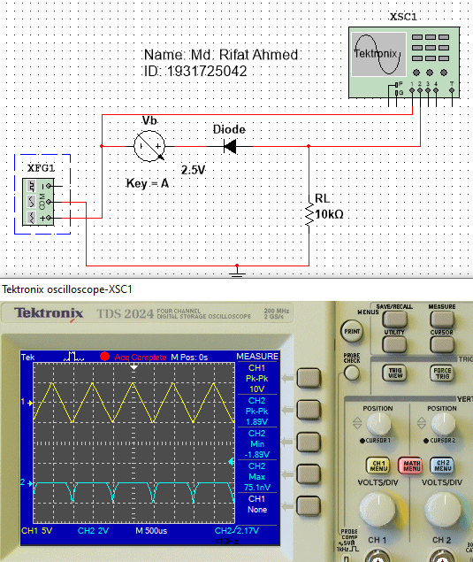

Figure 1: Series Clipper Circuit (Fig 4.6 (a))

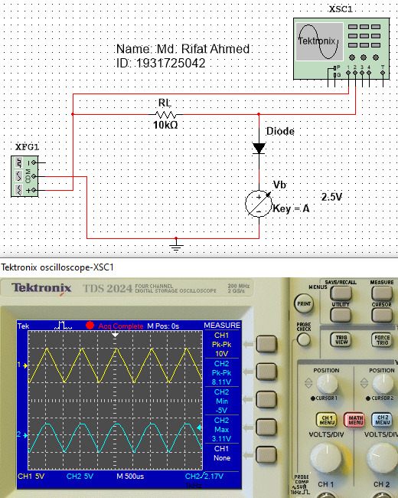

Figure 2: Parallel Clipper Circuit (Fig 4.7 (a))

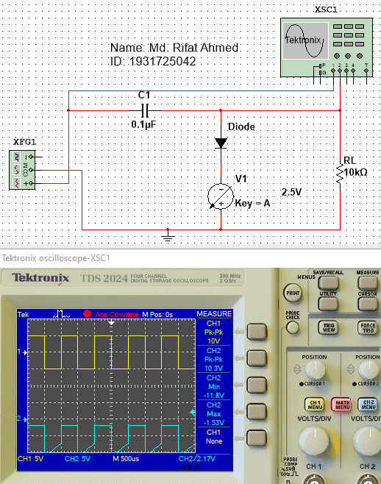

Figure 3: Clamper Circuit (Fig 4.8 (a))

Attach only waveforms below:

*[Take screenshots of input/ output waveforms of each simulated circuits]*



Figure 4: Input-Output Waveform of Fig 1



Figure 5: Input-Output Waveform of Fig 2



Figure 6: Input-Output Waveform of Fig 3

**References:**

Storr, W. (2018, April 6). Diode Clipping Circuits and Diode Clipper. Basic Electronics Tutorials. <https://www.electronics-tutorials.ws/diode/diode-clipping-circuits.html>

Manoel, V. (2020, August 3). Boylestad - Electronic Devices and Circuit Theory 11th txtbk. Passei Direto. <https://www.passeidireto.com/arquivo/80938598/boylestad-electronic-devices-and-circuit-theory-11-th-txtbk/31>

Electronic Circuits - Clamper Circuits - Tutorialspoint. (2020). EEE. <https://www.tutorialspoint.com/electronic_circuits/electronic_clamper_circuits.html>